IT Help Desk Database

Kenneth Yan

Deborah Barndt

Illinois Institute of Technology

ITMD-411 Final Project

Prof. James Papademas

3 December 2016

Table of contents

Brief description of program………………………………………………………………………3

Snapshots………………………………………………………………………………………….4

Java source code docs………………………...……Please see attached 3 doc files on Blackboard

Conclusion……………………………………………………………………………………….12

Description

This java program creates a database for the Geekbit IT Help Desk trouble ticket system. It allows you to login, create, view, update, delete, and view all tickets. It also contains the contact information of the users and the login information of each user.

Snapshots

Create a ticket:

Ticket Subject

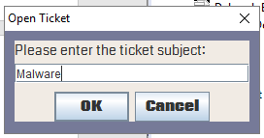

Ticket Description

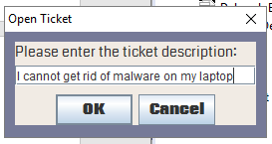

Ticket Priority

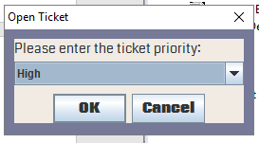

Ticket Created Confirmation

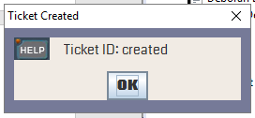

View the ticket that was created

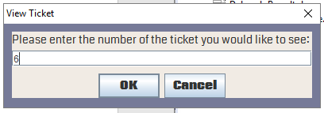

View of the ticket that was created

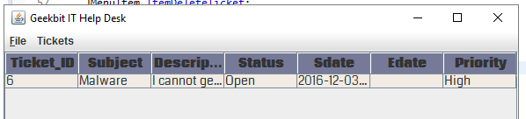

View of all 5 trouble tickets created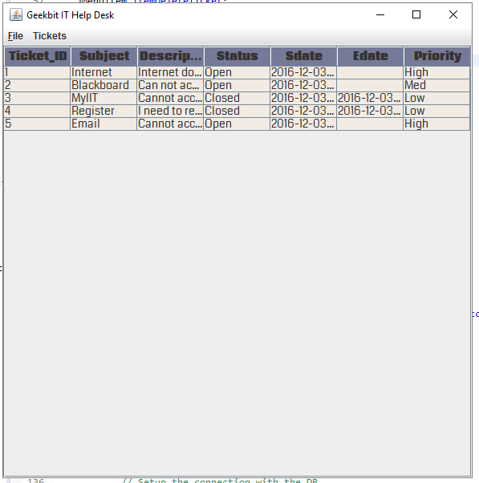

Closing a ticket

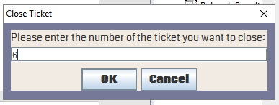

Message that a trouble ticket was closed

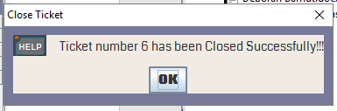

Update a ticket

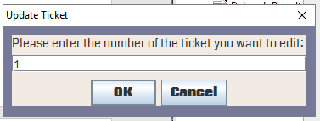

Entering the updated ticket subject

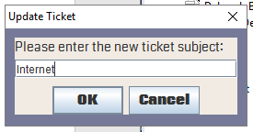

Entering the updated ticket description

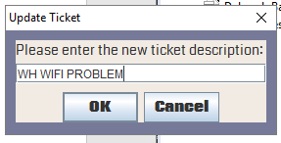

Choosing the new ticket status of the updated ticket

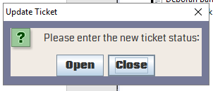

Ticket updated confirmation

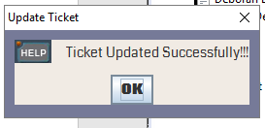

Choosing the ticket to view that was updated

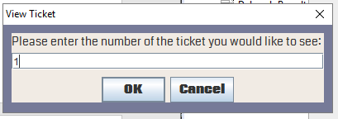

View of the updated ticket

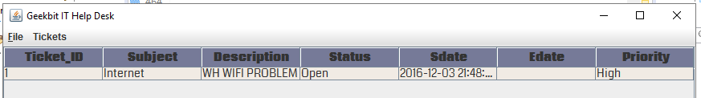

Deleting a trouble ticket

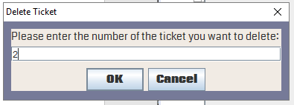

Confirming with the user that they want to delete the ticket

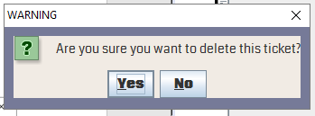

Confirmation that the ticket was deleted

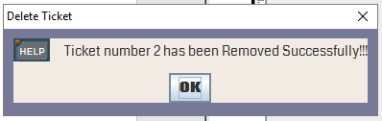

View of all the trouble ticket records presented in a JTable

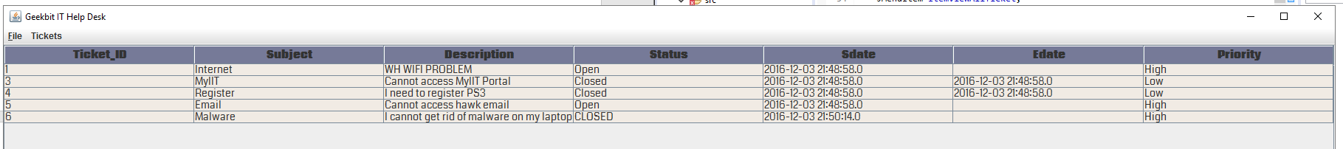

Login screenshot of the Geekbit IT Help Desk Login

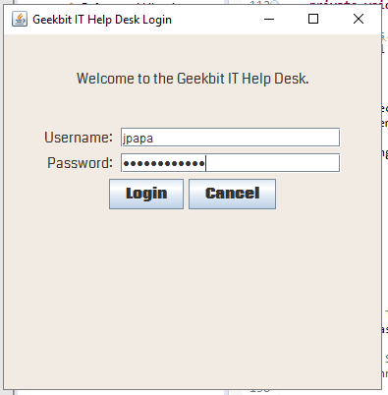

The console report of the duration of time all open tickets have existed, the ratio of closed to open tickets

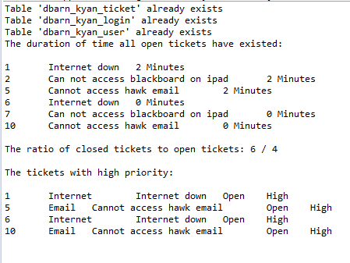

Tickets Table in the database

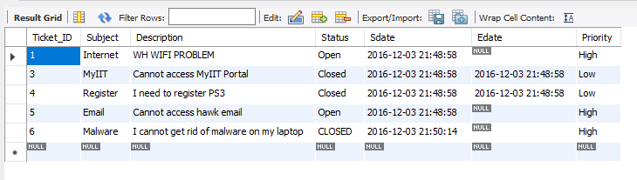

Login Table in the database with password hashing

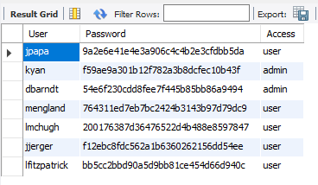

User Table in the database with user information

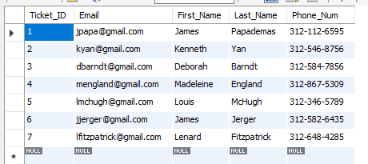

Conclusion

With the completion of this java program. Geekbit IT will now efficiently be able to login, and be able to keep track of all trouble tickets that are made by the users by using the Geekbit IT Help Desk that was created by Deborah Barndt and Kenneth Yan on December 3, 2016.